# **SECTION 1. CONTEXT**

MOVE BOTH 2001 AND 2015 ACKNOWLEDGEMENTS TO APPENDIX

**2001 ACKNOWLEDGEMENTS:**

***La Cienega Valley Association Board Of Directors***

|  |  |  |
| --- | --- | --- |
| **Robert Romero, President**  **Camille Bustamante, Secretary Grey Howell**  **José Varela Lopez**  **Marilyn Ballard**  **Kathleen McCloud** | **Karla Blaine**  **Lucielle Romero Charlie C' de Baca**  **Reynaldo Romero Andres Carrillo**  **Billy Schenk**    ***La Cienega and La Cieneguilla Planning Committee*** | **Carl Dickens**  **Vioma Trujillo**  **Tom Dixon**  **Jasper Vassan**  **Linda Hayne** |
| **Pete Ayala**  **Marilyn Ballard**  **Jim and Karla Blaine**  **Carnille Bustamante**  **Barbara C' de Baca**  **Charlie C' de Baca**  **Daniel C' de Baca**  **Andres Carrillo**  **Elaine Cimino**  **Tom Dixon**  **Carl Dickens** | **Alonzo Gallegos**  **JJ Gonzalez**  **Linda Grill**  **Grey Howell Tom Kellie**  **Judy Kowalski**  **Mary and Leonard Montano**  **Joe Orr Isaac Pino**  **Carl Potter**  **Rey Romero**  ***Santa Fe County*** | **Robert Romero**  **Billy Schenk**  **Tom Simons**  **Michael Romero**  **Taylor**  **Warren Thompson**  **Vioma Trujillo**  **Richard Valerio**  **Charlie Velarde**  **Gilbert Vigil**  **Jose Villegas**  **José Varela Lopez**  **Dan Wallender** |

**Commissioner Marcos Trujillo, District 1 Commissioner Paul Duran, District 2 (Chairman) Commissioner Javier Gonzales, District 3 Commissioner Paul Campos, District 4 Commissioner Jack Sullivan, District 5**

##### Samuel O. Montoya — County Manager Estevan Lopez - Land Use Administrator Jack Kolkmeyer - Planning Division Director Judy McGowan - Planner III Alina Bokde - Planner II Paul M. Olafson - Planner I (Co-Lead Planner) Robert Griego - Planner I (Co-Lead Planner) Kenny Pin - Lead Planner (1998-2000) Penny Ellis-Green, Development Review Specialist III Katherine Yuhas, County Hydrologist Erle Wright - GIS Director Jim Gallegos – GIS Technician

**NOTE: The original Community Plan document was adopted in August, 2001. A copy of that document is available at the Santa Fe Office of the County Clerk, Book 2064/2065, pages 960-020.**

**2015 ACKNOWLEDGEMENTS:**

***La Cienega Valley Association Board Of Directors***

##### Carl Dickens, President Keir Careccio JJ Gonzales Mary Winter, Secretary Mary Dixon Reynaldo Romero Paul Murray, Treasurer Kathryn Becker Robert Romero Linda C de Baca Grill Judith Hands

***La Cienega and La Cieneguilla Planning Committee***

|  |  |  |
| --- | --- | --- |
| **Gene Bostwick, chairman Kathryn Becker**  **David Camp**  **Tom Dixon** | **Rick Dumiak**  **Alonzo Gallegos**  **Tino Gallegos**  **JJ Gonzales** | **Stan Jones**  **Sylvia LeMaster**  **Robert J. Romero, Pojoaque Pueblo José Varela-Lopez**  **Ivan Trujillo** |

**2015 La Cienega and La Cieneguilla Planning Participants**

|  |  |  |  |
| --- | --- | --- | --- |
| **Martin Najera**  **Cyril Siltala**  **Orlando Roybal** | **Melissa Garcia**  **Noah Berke**  **Juanita Mevi** |  | **John Mevi**  **Vicente Marchi**  **Ida Campos** |
|  |  |  |  |

***Santa Fe County***

|  |  |
| --- | --- |
| **Commissioner Henry Roybal, District 1** | **Kathryn Miller - County Manager** |
| **Commissioner Miguel Chavez, District 2** | **Penny Ellis-Green - Growth Management Director** |
| **Commissioner Robert Anaya, District 3** | **Vicki Lucero - Building Development Manager** |
| **Commissioner Kathy Holian, District 4** | **Robert Griego - Planning Manager** |
| **Commissioner Liz Stefanics, District 5** | **Sarah Ijadi - Senior Planner**  **Tim Cannon – Senior Planner/G.I.S.**  **Amy Rincon – Community Planner**  **Claudia Borchert - Utilities Division Director** |

## **1.1 INTENT AND PURPOSE OF THE PLAN**

The intent of this plan is to reinforce the unique, historical, rural character of the plan area while serving evolving community needs through a mix of policies, projects, and programs.

The purpose of this plan is to:

* Document and map changes from 2015 through 2024 and analyze impacts.
* Revisit elements, strategies and recommendations identified in the 2015 La Cienega and La Cieneguilla Plan Update.
* Establish a future land use map, categories and general provisions to guide future development, and land use policy
* Identify projects, programs and strategies that support the community’s vision and goals.
* Provide recommendations to guide zoning and development standards for incorporation into the SLDC. These standards will define the La Cienega and La Cieneguilla Community District “Overlay” which will replace the La Cienega and La Cieneguilla Santa Fe County Ordinance 2002-9.
* Provide a community action plan to further the Community vision and solve problems on an ongoing basis with an emphasis on developing collaborative relationships between residents, local, state federal governments, public agencies and community organizations.

## **1.2. COMMUNITIES VISION STATEMENT**

Building upon the 2001 and 2015 Plan Vision Statement, members of the community developed a revised Vision Statement that recognizes the multiple communities in the planning area, makes minor clarifications, and reformats the statement.

*The villages of La Cienega and La Cieneguilla have unique histories, but we share a vision of a peaceful and rural community that respects diversity and is governed through unity.*

*We will protect our natural environment, air and water resources, and unique character by honoring and preserving our traditional culture and the area’s historical, agricultural, livestock, and rural low-density residential development traditions.*

*We will maintain our self-sufficiency and protect our community from impacts of urban developments.*

*We will live in a community where people of all cultures and incomes share in decision making.*

*We will live in a community where any changes, improvements, and decisions are informed by a realistic understanding of our available resources and our vision of a relaxed and open quality of life.*

This document is the 2025 La Cienega and La Cieneguilla Communities Plan. When adopted it will amend the County’s SGMP and replace the 2015 La Cienega and La Cieneguilla Community Plan Update.

As an amendment to the SGMP, this plan guides land use policy for the area and provides the framework for future zoning and development regulations, capital projects, programs, and services.

## **1.2 INTENT AND PURPOSE OF THE PLAN**

The intent of this plan is to reinforce the unique, historical, rural character of the plan area while serving evolving community needs through a mix of policies, projects, and programs.

The purpose of this plan is to:

* Document and map changes from 2015 through 2024 and analyze impacts.
* Revisit elements, strategies and recommendations identified in the 2015 La Cienega and La Cieneguilla Plan Update.
* Establish a future land use map, categories and general provisions to guide future development, and land use policy
* Identify projects, programs and strategies that support the community’s vision and goals.
* Provide recommendations to guide zoning and development standards for incorporation into the SLDC. These standards will define the La Cienega and La Cieneguilla Community District “Overlay” which will replace the La Cienega and La Cieneguilla Santa Fe County Ordinance 2002-9.
* Provide a community action plan to further the Community vision and solve problems on an ongoing basis with an emphasis on developing collaborative relationships between residents, local, state federal governments, public agencies and community organizations.

## 

## **1.3 KEY ISSUES**

Many issues identified in the 2015 Plan are still relevant today and are brought forward in this update. Among these ongoing and primary concerns are the reduction of the planning area’s surface and ground water resources and a continued desire to preserve and enhance the rural character related to residential development, roads, open space, agriculture and the acequia systems.

This plan update also identifies new issues pertaining to growth both within and adjacent to the plan area, particularly the need to coordinate and plan for increased commercial activities both within and adjacent to the plan area, including the areas associated with the Santa Fe Downs, Erica Road, the Airport, I-25/NM 599 interchange, and Ojo Santa Fe.

Additionally, this update addresses issues and opportunities associated with changes that have occurred over a decade in the County’s land use and policy framework. As a result, this document is consistent with the Sustainable Growth Management Plan, Sustainable Land Development Code, and related ordinances.

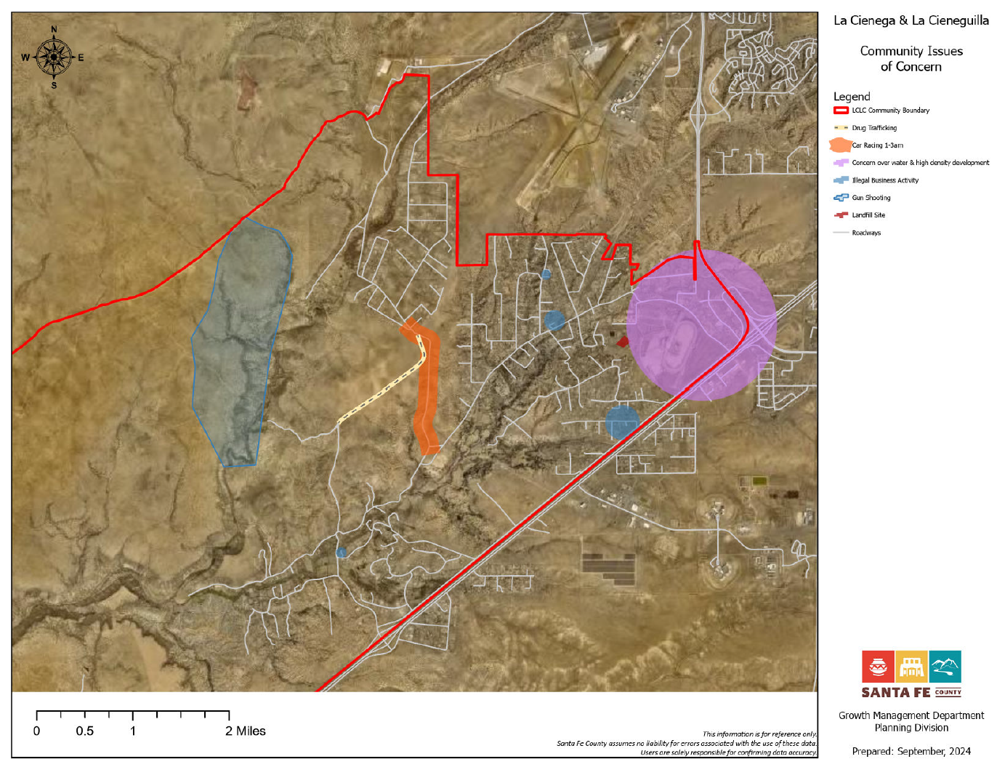

## **1.4 MAJOR RECOMMENDATIONS**

Many recommendations of the 2001 and 2015 Plans have been implemented through a variety of public and private actions, zoning regulations, capital improvement projects and programs. Recommendations that have not been fully implemented and are still relevant have been brought forward in this update, combined with new ones. Major recommendations include:

* Implement La Cienega Watershed Water conditions fully by seeking the extension of Santa Fe County water lines to serve existing and future residential and commercial uses in Upper La Cienega.
* Preserve and protect traditional agricultural and ranching activities through various means, including incentives such as site development standards, density bonuses and transfers.
* Allow cluster development and density transfers in conjunction with agricultural, archeological and open space conservation easements.
* Establish a bus route through the community that provides connections to the Railrunner Station and to City bus routes on Airport Road.
* Maintain the rural character of roads and increase pedestrian, vehicular and equestrian safety.
* Preserve and protect traditional agricultural and ranching activities through various means, including incentives such as site development standards, density bonuses, and transfers.
* Allow cluster development and density transfers in conjunction with agricultural, archeological and open space conservation easements.
* Ensure that any density increases and/or bonuses take into account all issues into consideration, including water, wastewater, neighborhood surroundings, access, traffic, utilities, history, etc.
* Establish a commercial district on properties on properties associated with the NM 599/I-25 Interchange and Santa Fe Downs.
* Establish community pathways and equestrian trails along existing road network to connect with existing and planned regional trail systems, open space and community facilities.
* Conduct a water/sewer feasibility study for the plan area to analyze utility service options to consider all possible methods of serving the area over the long term including on-site systems, (primarily well and septic), community systems and extensions of the Santa Fe County water and wastewater systems.
* Initiate Public Improvement District or other funding mechanisms to finance infrastructure projects in existing areas with deficiencies.

## 1.5 DOCUMENT GUIDE

## **1.5 PLANNING AREA BOUNDARY**

#### 1.6.1 Boundary Purpose

The physical boundaries of the Planning Area are designed to recognize the traditional uses of the land and how development would impact the communities. Expansion of the City of Santa Fe and possible annexation of the Planning Area’s communities threatened many of the grazing lands and open lands connecting the villages which are crucial to the fabric of the communities. Through discussion by the 2001 Planning Committee, historic and rural importance was assigned to these areas.

#### 1.6.2 Boundary Status

The planning area boundary follows the La Cienega Traditional Historic Communities boundary that was established by Santa Fe County Ordinance 2000-07 (See Appendix) in accordance with State Law (NMSA 1978, Section 3-21-1) which recognizes the historic importance of the area and prevents annexation by the City of Santa Fe.

#### 1.6.3 Boundary Description

The planning area is the same as the area included in the 2001 and 2015 Community Plan boundary. The boundary follows the upper edge of the La Bajada escarpment on the south, follows topographic features and County Road 56 C to the west and north, the southern airport boundary and NM State Highway 599 to the north and east, and Interstate 25 to the east and south. (See Map 1: La Cienega and La Cieneguilla Planning Area.). Within the core of the planning area the 1980 Santa Fe County General Plan delineated a Traditional Community Zoning District.

# **SECTION 1.6 COMMUNITY PLANNING HISTORY AND PROCESS**

The Planning Area is comprised of Lower La Cienega, Upper La Cienega and La Cieneguilla and surrounding areas. These rural communities in Santa Fe County share a long, enduring history, a scenic rural environment and a tradition of working together through discussion, education, listening and negotiation to solve problems and plan for the future by creating a community plan that encourages sensible and sustainable growth. In the late 1990’s the communities began an in-depth community planning process that resulted in the adoption of the 2001 La Cienega and La Cieneguilla Community Plan and corresponding 2002-9 Ordinance.

Much has changed since the 2001 Community Plan and corresponding ordinance were adopted. Population has increased 27% from 3,007 people in 2000 to 3,819 people in 2010. Correspondingly, 261 new homes were added and commercial development in southern portions of the City of Santa Fe and areas adjacent to the valley has greatly intensified. In 2010, the NM Rail Runner Station at the interchange of NM 599 and I-25 just northeast of the plan area opened with over 200 parking spaces and bus connections to Los Alamos and Santa Fe, making it an important regional transit hub for northern New Mexico. These factors combined with the explosive residential growth of the 1990’s have resulted in a population size equal to or greater than many incorporated New Mexico communities and towns.

Additionally, Santa Fe County’s legal framework and policies for land use, growth management and development have changed since the 2001 Community Plan was adopted. In late 2010, the Board of County Commissioners, (BCC), adopted the Sustainable Growth Management Plan (SGMP). In December 2013 the BCC adopted the corresponding Sustainable Land Development Code (SLDC) which when in effect will replace the 1996-10 Land Development Code and implement many of the policies from the SGMP. Most significantly, the new code presents a shift from the County’s current hydrologic zoning, which regulates density based on water availability, to a fixed zoning scheme. To implement the new code and zoning scheme, the County will assign zoning districts and adopt a corresponding zoning map following criteria identified in the SGMP including water resources, proximity to public utilities, community character, existing and compatible land uses, densities and lot sizes. For areas such as La Cienega and La Cieneguilla covered by adopted plans and ordinances, the County will work with communities to assign base zoning districts and overlay zones as outlined in Chapter 9 of the SLDC. Both the SGMP and SLDC will guide land use and regulate development throughout the County for years to come.

In early 2011, in response to the adoption of the County’s new General plan (the SGMP), Planning Area community members recognized the need to revisit the 2001 La Cienega and La Cieneguilla Community Plan, and corresponding 2002-9 Santa Fe County La Cienega and La Cieneguilla Community District Ordinance. Over the course of several years, members of the community and the County worked together to assess changes in the area, update information, identify issues, and revise and develop strategies to manage growth and development in accordance with the SGMP and SDLC.

[Add a paragraph about the 2024-25 community planning process]

## **SECTION 1.7 EXISTING CONDITIONS & TRENDS**

## **2.1 A BRIEF HISTORY AND DESCRIPTION OF THE PLAN AREA**

The history of the Planning Area and its traditional historic communities of La Cienega and La Cieneguilla date back thousands of years. As the name Cienega (Spanish for marsh) implies, the La Cienega Valley contains marshlands formed by natural springs that have attracted passersby and settlers since well before the time of Christ. Archeological surveys conducted over the years yielded archaeological sites ranging from camp sites of the Archaic Period five thousand years ago to ruins of an early 20th century ~~school house~~schoolhouse. This high level of archeological site density is indicative of numerous ancient settlements throughout the valley. ~~Overall~~Overall, the Planning Area has one of the highest concentrations of historic occupations in the Santa Fe vicinity.

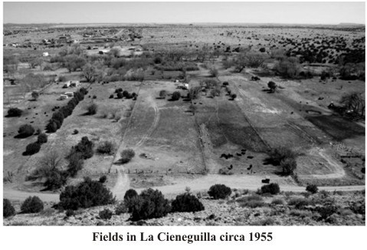

The oldest traces of human use can be found on the slopes overlooking the numerous springs in the area. The mesa escarpments are dotted with petroglyphs and rock etchings that date as far back as three thousand years, when American Indians took advantage of the ~~ever present~~ever-present water so vital to us even today. About the time of Christ, people began living in pit houses presumably on a ~~year round~~year-round basis. Over the centuries, people began the transition of living in surface structures made of puddled adobe or stone, or a combination.

At the time of Spanish contact in the late 16th century, there was mention of at least two considerably large Indian Pueblos in the Planning Area referred to as “La Cienega” and “La Cieneguilla”. La Cienega continued to be inhabited through the 17th century by Tano Indians. La Cieneguilla was abandoned by the Keres Indians in the early 1600’s but subsequently reoccupied by the Spanish in the 1630’s. The location of the Cieneguilla Pueblo is in the present village of La Cieneguilla whose mesas are adorned “with petroglyphs inscribed over thousands of years.” La Cienega is located on the mesa adjacent to the confluence of the Santa Fe River and La Cienega Creek.

The earliest known Spanish settlement in the valley is the ‘Sanchez Site” otherwise known as LA, 20,000 dating from 1630 to the time of the Pueblo Revolt in 1680. It is a very important site located in the southern part of the valley that was partially excavated in the 1980’s and is now owned and protected by El Rancho de Las Golondrinas. Other pre-revolt estancias are known to have existed at that time, although none have been located. Collectively the numerous archaeological sites constitute a concentration of historic resources that need to be protected and preserved. The Galisteo Basin Archaeological Sites Protection Act passed by Congress and signed into law on March 19, 2004 includes La Cienega and La Cieneguilla Pueblos and is in the process of developing a management plan that will offer federal protection for these sites. Other significant sites within the boundaries of the planning area may be worthy of inclusion in the Act. It is important to note that this protection is only on publically owned lands.

While the communities of La Cienega and La Cieneguilla are both located within the Planning Area, the Spanish settlement of each village was very different. La Cienega rapidly increased in population due to the fact that common lands were easily settled and the availability of water. The village of La Cieneguilla, along the Camino Real, was initially settled by Spanish colonists to the west of the Santa Fe River shortly after the arrival of Don Juan de Oñate to the area late in the 16th century. The east side of the river was the site of both historic and prehistoric Keresan pueblos.

The original grantee, Francisco Anaya De Almazan, was conferred title to over three thousand acres by Don Diego De Vargas in 1693. The property was sold in June of 1716 to the extended Montoya family. Increased population during the 19th century prompted the settlement of families to the east side of the Santa Fe River, in the vicinity of the then abandoned pueblo, as seen on the U.S. surveyor general’s map from the late 1800’s(below). Farming and ranching on the La Cieneguilla Land Grant was a major area of food production for the population in the Villa de Santa Fe.

Extensive settlement of La Cieneguilla did not occur until some 50 years after the Anaya De Almazan family sold the grant. Currently, the remaining traditional land of the grant is located near the mouth of the Santa Fe River.

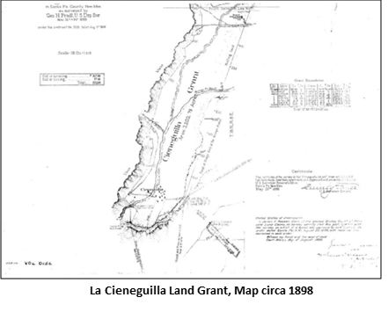

After the Spanish reconquest in 1692 and throughout the Spanish Colonial period, various place names are recorded for a number of ranchos in the Planning Area including “Guicú,” “Los Tanques,” “Las Golondrinas,” “El Alamo,” “La Capilla Vieja” and “El Cañon.” The springs that seep throughout the valley made these areas very desirable for ranching and grazing. In addition, El Rancho de Las Golondrinas was a major paraje (stopping place) on the Camino Real de Tierra Adentro that traversed along the Santa Fe River serving as the first stop leaving Santa Fe when traveling south and the last stop for travelers before entering Santa Fe coming north. Even today, remains of the trail ruts can still be seen in the La Cienega Valley. The names of the early Spanish settlers are ones that are prevalent today in the valley: Baca, Bustamante, C’ de Baca, Delgado, Gonzales, Montoya, Ortiz, Perea, Pino, Rael, Romero, and Sanchez to name a few.

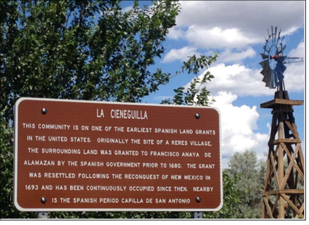

###### **La Cieneguilla Historical Marker Sign 2015**

The Planning ~~Area continued~~Area continued to be used for farming and ranching in the 19th century and up to the present. The valley was a busy place in the 19th century as reflected in the census of the time. By World War II, with the development of better roads, motor vehicle travel enabled the economy of the Planning Area to change. More and more people found work in Santa Fe and families sent their children there for schooling. By the early 1980’s, the settlement patterns of La Cienega and La Cieneguilla were changing dramatically; more affordable land was located in this part of the Santa Fe area where families could live. The area was caught in an incredible surge of residential development that included residential population growth and in-migration, Table 1 displays this growth. Although the rate of growth has slowed in recent years, the repercussions to the cultural landscape of the valley are ongoing.

What does this all mean? It means that the Planning Area has always been a desirable place for people to live, raise their families, grow their crops, graze their livestock and welcome strangers. It means that we in the valley have become stewards of a cultural landscape that has nurtured our forebears and welcomed recien emigrados (recent émigrés) to the valley for centuries. It means we have a responsibility to preserve as best we can the lay of the land, the water and its traditions, while at the same time allowing controlled growth to take place that respects one’s neighbors.

## **2.2 COMMUNITY PROFILE AND DEMOGRAPHICS**

#### **2.2.1 Population Growth**

Total Population Growth in population for the plan area from ~~1990 to 2010~~2010 to 2020 has been relatively ~~high~~ low for the County. As Table 1 describes, the La Cienega Planning Area CDP (census dedicated place), which includes most of the populated portions of the plan area, grew substantially between 2000 and 2010 (27%) however from 2010 to 2020 the population only grew 1.69%. The 27% population increase observed between 2000 and 2010, while substantial is actually a less dramatic increase than occurred in the 1990’s, though significantly greater than the population growth experienced in 2010-2020. Between 1990 and 2000 the population increased from 1,775 to 3,007 representing a 69% increase. In general, La Cienega Planning Area has a growing population as result of both residential population growth and in-migration, but the rate is slowing. As Table 2 describes, two decades of growth in the community has resulted in a population size equal or greater than many incorporated New Mexico communities and towns.

Table 1: La Cienega CDP POPULATION



La Cienega CDP Population changes between ~~1990~~ 2010 & 202~~1~~0

|  |  |  |  |  |  |
| --- | --- | --- | --- | --- | --- |
| 1990 | 2000 | 2010 | 2020 | Change 1990-2010 | Change ~~2000~~2010-202~~1~~0 |
| no. of people | no. of people | no. of people | no. of people | % change | % change |
| 1775 | 3007 | 3819 | 3885 | 69% | ~~27~~1.69% |
| Source: 1990, 2000, ~~and~~ 2010 and 2020 Census | | ~~Census~~ |  |  |  |

Table 2: Population of other small New Mexico towns and communities

|  |  |
| --- | --- |
| ***Community/Town*** | ***Population*** |
| Chama Village, Rio Arriba County | ~~1,022~~917 |
| Agua Fria, Santa Fe County* | 2,913~~800~~ |
| City of Santa Rosa, Guadalupe County | 2,850~~48~~ |
| Town of Clayton, Union County | 2,645~~980~~ |
| Village of Chimayo, Santa Fe and Rio Arriba County* | 3,0~~1~~77 |
| Town of Edgewood, Santa Fe County | ~~3,735~~6,174 |
| La Cienega and La Cieneguilla, Santa Fe County* | 3,885 |
| Village of Bosque Farms, Valencia County | 4,020~~3,904~~ |
| Town of Taos, Taos County | ~~5,716~~6,474 |
| Los Ranchos de Albuquerque Village, Bernalillo County | 5~~6~~,874~~024~~ |

Source: 202~~1~~0 Census

*Unincorporated communities within Santa Fe County

#### **2.2.2 Housing Characteristics**

Growth in housing units also is also relatively high for the County, as seen in Table 3. According to both the census and County data on residential structures, the number of units has increased 24% from approximately 1079 units in 2000 to approximately 1340 units in 2010. The percent of owner occupied units and rental units has remained the same while number units that are vacant has increased slightly to 6% but is relatively low compared to the County vacancy rate of 13%.

Table 3: Change in La Cienega Housing Characteristics – 2000 to 2010

|  |  |  |  |  |  |  |  |
| --- | --- | --- | --- | --- | --- | --- | --- |
|  | 2000 | | 2010 | | 2020 | Change 2010-2020 | |
| no. of units % of total | | no. of units % of total | | no. of units % of total | no. of units % change | |
| Occupied Housing | 1033 96% | | 1259 94% | | 1,483 38% | 226 17% | |
| Vacant Housing | 46 | 4% | 81 | 6% | 100 2.5% | 35 | 23% |
| Owner Occupied | 800 | 77% | 966 | 77% | 1102 36% | 166 | 14% |
| Renter Occupied | 233 | 23% | 293 | 23% | 281 7.2% | 60 | 4% |
| Occasional Use Housing | 9 | 1% | 12 | 1% | 15 0.3% | 3 | 25% |

Source: 2020 Census

#### **2.2.3 Age Structure and Ethnicity**

Compared with the community’s population and housing growth figures, other population characteristics, such as age structure and ethnicity have been more stable (see Table 4). The percent of the population that identifies as Hispanic or Latino has increased from 9% from 2000-2010 while the percent of the population that identifies as not-Hispanic or Latino has decreased by 9%. The percent of individuals under the age 18 has remained the same while the percent of population ages 50-64 has increased 6% and the percent over 65 has increased 3%. Continued increases the elderly population may increase the need for community services in the area.

Table 4: Change in Ethnicity and Age distribution between 2000 and 2010

|  |  |  |  |  |  |  |
| --- | --- | --- | --- | --- | --- | --- |
|  |  | Ethnicity | |  |  | |
|  | 201~~0~~0 |  | | 202~~1~~0 | change 201~~0~~0-202~~1~~0 | |
|  | N~~n~~o. of people | % of total pop. | No. of people | % of total pop. | Change in pop. | % change |
| Hispanic or Latino | ~~2129~~ 3069 | ~~71~~80% | ~~3069~~ 2922 | ~~80~~75% | -~~940~~ 147 | ~~44~~4.7% |
| Non-Hispanic or Latino | ~~878~~ 750 | ~~29~~20%    Age | ~~750~~ 963 | ~~20~~25% | ~~-128~~213 | ~~-15~~28.4% |
|  |  |  |  |  |  |  |
| under 19 | 1292~~1017~~ | 34% | 940~~1292~~ | 24~~34~~% | -~~275~~ 352 | -27.2% |
| 20-24 | 205~~182~~ | 5~~6~~% | 262~~205~~ | 6.7~~5~~% | 57~~23~~ | 27.8~~13~~% |
| 25-34 | 440~~458~~ | 15% | 435~~440~~ | 11.2~~5~~% | -5~~18~~ | -1~~4~~% |
| 35-54 | 1132~~1025~~ | 30~~4~~% | 1019~~1132~~ | 26.3~~30~~% | -113~~07~~ | -9.9~~10~~% |
| 55-64 | 477~~196~~ | 12.5~~7~~% | 598~~477~~ | 15.4~~12.5~~% | 121~~281~~ | 25.~~14~~3% |
| 65 & over | 273~~129~~ | 7~~4~~% | 631~~273~~ | 16.3~~7~~% | ~~144~~ 358 | 131~~112~~% |

Source: 201~~0~~0 and 202~~1~~0 Census

### **2.2.4 Employment**

The limited amount of commercial development and community services in La Cienega Planning Area may limit employment opportunities available within the community. Most working residents travel outside the community for work. Average commute times are about 23% higher in La Cienega Planning Area than in Santa Fe County as a whole and most La Cienega Planning Area residents work in industries that are unevenly represented in the community. However, the significant number of residents who work from home in the community (about 8%) may mean that opportunities for home based businesses may ameliorate the spatial mismatch between jobs and housing in the community. Key employment characteristics are described in Table 5.

Table 5: 202~~1~~0 Estimates of La Cienega CDP Community Employment Characteristics

|  |  |  |
| --- | --- | --- |
| Percentage unemployed | ~~3.2~~6.1% | |
| Percentage who work from home | ~~8.1~~5.2% | |
| Mean travel time to work | 26.4~~2~~ minutes | |
| Median income | $~~51,891~~65,549 | |
| Percentage employed in construction | ~~19.9~~15.2% | |
| Percentage employed in public administration | | ~~18.0~~7.0% |
| Percentage employed in educational services, heath care and social assistance | | ~~17.5~~13.9% |
| Percentage employed in professional, scientific, management, administrative, and waste management services | | ~~8.2~~12.5% |
| Percentage employed in arts, entertainment, and recreation, accommodation, and food services | | ~~7.0~~14.8% |
| Percentage employed in retail trade | | ~~6.9~~11.1% |
| Percentage employed in transportation and warehousing, and utilities | | ~~6.9~~4.3% |
| Percentage employed in other services (except public administration) | | ~~4.8~~9.4% |
| Percentage employed in finance, insurance, real estate, and rental and leasing | | ~~3.5~~10.3% |
| Percentage employed in agriculture, forestry, fishing and hunting, and mining | | ~~3.4~~0.5% |
| Percentage employed in wholesale trade | | ~~1.9~~0.0% |
| ~~Percentage employed in public administration~~ | | ~~1.8%~~ |
| ~~Percentage employed in educational, health and social services~~ | | ~~1.8%~~ |
| Percentage employed in information | | ~~1.5~~0.0% |
| Percentage employed in manufacturing | | ~~0.5~~1.1% |

Source: ~~2006-2010~~2020 American Community Survey 5-Year Estimates

## **2.3 HISTORIC & CULTURAL RESOURCES**

La Cienega’s rich cultural heritage is evident in the continuation of agriculture production in the community, the continued use of the historic acequia systems, local building form and patterns, community traditions, and the many families with histories going back for generations. Historic structures including churches, cemeteries, capillas, homes, barns, corrals, and cisterns, dot the landscape and many are still in use and highly valued by community members. The community values historic resources and actively protects and maintains historic structures and by collaborating in the acquisition and management of historic sites and public lands.

Collectively the numerous archaeological sites constitute a concentration of historic resources that need to be protected and preserved.

Significant sites within the plan area include:

* La Cienega Pueblo and Petroglyphs- The La Cienega Pueblo dates to A.D. 1100- 1300. It contains over 140 rooms and over 1,000 petroglyphs. The site is not accessible to the public.
* La Cienega Pithouse Village- The La Cienega Pithouse dates to A.D. 700-900. It is not accessible to the public.
* La Cieneguilla Petroglyphs & Camino Real de Tierra Adentro- The Camino Real de Tierra Adentro provided connections among native peoples prior to European contact, and later between colonial Mexico City and Santa Fe. Extensive petroglyphs are associated with the trail.
* La Cieneguilla Pueblo- The La Cieneguilla Pueblo dates to 1325-1600. The Pueblo was abandoned and resettled and eventually had a Spanish and Mexican village built on it. It is not open to the public.

Since the 2001 plan was adopted, the Bureau of Land Management has made significant land purchases to expand their holdings in the Planning Area and further protect the community’s historical as well as natural resources. The agency, in cooperation with community members and other governmental bodies, has also developed a plan to manage the community’s land resources. Portions of La Cienega and La Cieneguilla also are covered by the “La Cienega Area of Critical Environment Concern,” a BLM designation that formally signifies a need for land management to protect “national significant cultural resources as well as riparian, wildlife and scenic values.”

Other public lands significantly contribute toward preserving the community’s historical resources.

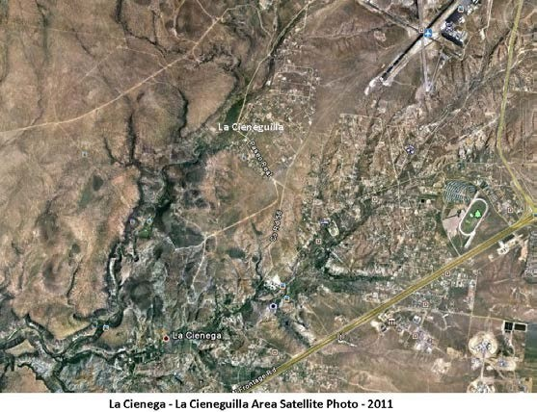Santa Fe National Forest land, BLM land, and Santa Fe County Open Space land all contain portions of the Camino Real. Although only the BLM petroglyph site has interpretative resources to facilitate public visitation of historical resources, all public lands in the area are managed with an objective to protect the community’s uniquely valuable cultural resources.

In addition, El Rancho de Las Golondrinas Living Museum, located on a historic local hacienda, has been operated by a local nonprofit organization for over forty years. This historic rancho, now a living history museum, dates from the early 1700s and was an important paraje or stopping place along the famous Paseo Real, the Royal

Road from Mexico City to Santa Fe. The

museum also includes and protects the “Sanchez Site” dating from 1630 to the time of the Pueblo Revolt in 1680. Partially excavated in the 1980’s, it is the earliest known Spanish settlement in the valley. Other pre-revolt estancias are believed to have existed in the area at that time, although none have been officially identified.