# **CHAPTER 2.1. LAND USE**

## 2.4 EXISTING LAND USE & DEVELOPMENT TRENDS (p. 24)

#### 2.4.1 Recent Development Trends

Traditionally, the rural and agricultural character of the La Cienega and La Cieneguilla Planning Area has shaped local settlement and land use patterns. Communities were formed along waterways to ensure irrigation for crops while upland areas were used commonly for grazing, wood collection and other household purposes. Early settlement by pre-pueblo and pueblo communities was characterized by compact housing areas near water sources. Beginning in the 1600’s, Spanish, Mexican and United States immigrants expanded development along the waterways and acequia systems as the population grew. Housing units were typically clustered in familial and community compounds. The primary land uses were for housing, irrigated agriculture and grazing. This type of land use required coordinated management and stewardship practices to maintain shared water resources and common lands or *ejidos* for livestock, timber and other uses. These agricultural and community traditions have defined where people built homes and how the community grew well into the 1900’s.

In the 1980’s and 90’s urban pressures from the City of Santa Fe’s growing population as well as internal growth from settled families spurred rapid residential growth in the plan area. New development intensified in upland areas near the intersection of NM State Highway 599 and Interstate 25 as well as in La Cieneguilla. Growth has also occurred in Upper and Lower La Cienega where traditionally irrigated lands have been converted to housing sites. The Planning Area became an attractive bedroom community for Santa Feans looking for the rural amenities of quiet living, low traffic, and open spaces.

From 2000 to present, growth is still influenced by close proximity to the City of Santa Fe, its desirable rural and historic character, a market preference for low-density single family housing, and low initial development costs relative to many other areas proximate to the City of Santa Fe. Increase in employment associated with the Community College District, the Airport, the National Guard and new commercial growth in Southwestern Sector of the City of Santa Fe may also be a contributing factor. Other factors may include proximity to transportation facilities including easy access to I-25, NM 599, NM Route 14 and the opening of the New Mexico Rail Runner Express station in 2010.

New development trends continue to pressure the Planning Area’s traditional rural character, farm fields, running acequias, and open spaces. The demand for new housing drives up real estate prices as well as property taxes on undeveloped and agricultural property, thereby making agricultural uses less viable. Community members have expressed that they feel overpowered by development and a lack of local control over land use decisions. One of the primary intents of the Plan is to protect and maintain the rural character and non-urban style development that makes the area special to residents while providing for community input in future land use decisions.

#### 2.4.2 Residential Land Use

With the exception of the public lands, a few private ranches, Las Golondrinas Living History Museum and the Santa Fe Downs Property, land uses in the planning area continue to be predominantly low-density, single family residential with a few large and medium sized parcels remaining in agricultural use. From 1990 to 2010, an estimated 404 new housing units were developed in the plan area, representing annual growth rate of 6%. With the exception of the Las Lagunitas subdivision in Lower La Cienega, most of the development occurred on existing lots, small subdivisions of fewer than 5 lots, lots created by family transfers, and infill of a large pre-1980 subdivision in La Cieneguilla, (see page 21, Figure 4: Existing Land Use Map).

Several factors will likely influence the rate of residential development in the plan area:

* *Available Land*, especially the transfer of private lands to public conservation lands. The transfer from private to public lands has significantly reduced the amount of land in the planning area available for single residential development. *Limited Water Resources.* In recent decades, several factors in the larger watershed and water supply of the region have come into play that are having and will continue to have impact on the plan area water supply. Decreases in rain and snowfall and increased temperatures have contributed to longer-term drought conditions. Several new studies and reports have confirmed continued drawdown of the aquifer generally, with increases in some isolated areas. Availability of regional water supplies through County and/or community systems may also be limited.

* *Market Conditions.* Between 2000 and 2010, the number of housing units in the planning area increased 24%, down from a 60% increase between 1990 and 2000. The slower pace of new development in recent years partly reflects the impact of the national recession. According to data from the Santa Fe Association of Realtors, home sales in the broader southwest Santa Fe County region (inclusive of La Cienega and La Cieneguilla, Madrid and Cerrillos) fell over 50% between 2005 and 2012 while median values decreased about 14% during the same period. County-wide, the number of building permits for new single family homes issued between 2005 and 2011 fell about 83%. Also a according to American Community Survey estimates, between 2000 and 2010, the median home value in La Cienega climbed about 56%. Incomes, however, haven’t necessarily increased. More people today are spending more of their incomes on housing in the planning area than ten years ago. According to the American Community Survey estimates, 45% of all 2011 mortgage holders in La Cienega and La Cieneguilla and 43% of all renters have housing costs (a measure which includes mortgage, rent, as well as estimate of utilities and other costs) that are 35% or more of their household incomes.

* *Zoning and Legal Regulations.* Santa Fe County’s recent adoption of the Sustainable Growth Management Plan and Sustainable land Development Code may represent significant changes in how development will occur. Establishment of zoning districts determines maximum densities which may not be adjusted to reduce lot sizes through signing of water restrictions.

* *County Purchase of Santa Fe Canyon Ranch.* In 2009, Santa Fe County acquired 470-acres of the Santa Fe Canyon Ranch property (also known as La Bajada Ranch) composed of several additional large parcels which comprise a total of approximately 1300 acres with an approved master plan for 156 single family residential units with a gross density of 2.58 acres per unit. The County has established a steering committee to review development options and potential uses. A 2010 survey of residents conducted by the County revealed a community preference for the property to be preserved as open space or developed with low-intensity land uses such as recreational facilities. The Master Plan was revised in 2014 to remove the large parcels and the remaining Master Plan consists of 470 acres.

* *Home Occupation Businesses:* Home occupation businesses continue to play an important economic role in the community. About 8.1% of residents work from home according to American Community Survey 5-year estimates. Small home-business scaled business operations include agriculture, a lodging facility, a furniture maker, and an upholstery shop among others. While home businesses have the potential to increase opportunities for commercial and employment services, concerns remain about their neighborhood impacts. For example, an asphalt and seal coating home business in La Cienega raised community concerns several years ago when they expanded their business and added heavy equipment storage.

#### 2.4.3 Agricultural Land Use

The rich legacy of agricultural production in the planning area includes grazing in dry upland areas as well as harvesting food, herbs, and tree crops along the waterways and acequias. Today, agricultural traditions are highly valued by community members and continue to reinforce the planning area’s rural heritage and historic character. Many residents tend gardens and fruit trees which yield substantial harvest for their household consumption. Even so, conversion of irrigable agricultural land to residential uses and home sites combined with declines in water flows in the acequia systems have led to a decrease in agricultural production.

#### 2.4.4 Commercial Land Use

Commercial services and employment opportunities in the community are limited. Other than RV and mobile home parks, open-yard commercial operations, a small number of home-based craft studios and shops, and the weekend Flea Market and farmers market at the Downs, there are no grocery stores, gas stations, or retail services in the plan area. As Table 6 makes clear, the number of commercial establishments is low relative to the number of commercial establishments in other small communities in the County.

Table 6: Commercial Land Use

|  |  |
| --- | --- |
| Community | % of parcels in commercial use |
| Pojoaque | 1.7% |
| Arroyo Seco | 6.2% |
| Agua Fria | 2.27% |
| La Cienega | 0.72% |

Source: Santa Fe County

The amount of commercial services in the plan area will be heavily influenced by utility extensions, water resources, transportation improvements, land use, and zoning regulations. Factors including changes in ownership or land use could have significant impact on the surrounding community and future development proposals. Major factors influencing commercial development include:

* *Medium to Large-Scale Commercial or Quasi-Commercial Properties:* A small number of medium-to-large scale business currently operate within the Plan area. In the Planning Area there are three properties that have current Master Plans with zoning approved from the Board of County Commissioners. These properties include:

* + Santa Fe Downs: The Santa Fe Downs property has a Master Plan and has traditionally hosted recreational or semi-commercial land uses. Currently, the property hosts concerts, equestrian activities, and has had a flea market on weekends and allows organized league play on the irrigated, grassy infield. The property is adjacent to most of the other commercial establishments in the community which is mostly located in Upper La Cienega and Santa Fe Downs is expected to produce a master plan in the nearterm that proposes more intensive development on the property.

* + Several properties between the Downs and the NM 599 / I-25 Interchange are used for open yard commercial and RV or mobile home parks.
  + Ojo Santa Fe: Sunrise Springs has a Master Plan and has lodging, restaurant, and retreat facility. The property has extensive gardens and water features and in the past has provided gallery space.

* + MCT: MCT has a Master Plan and is a commercial waste management facility that sorts and temporarily stores construction site waste and maintains a fleet of trucks and storage/collection containers on site.

* *Adjacent Commercial Development and other Uses Adjacent to the La Cienega Planning Area:*Several properties adjacent to the Planning Area have been developed or are slated for intensive development. These include:

* + Santa Fe Regional Airport.

* + The Pavilion business park, 371 acres located along N.M. 599 near the airport. This property is directly adjacent to the boundary of the La Cienega and La Cieneguilla Planning area.

* + 23 acre Komis property at northeast intersection of I-25 and N.M. 599.

* + Las Soleras, mixed use commercial and residential development, 550 acres located northeast of the outlet mall development.

* + National Guard complex on approx. 1,000 acres located across I-25 from the Las Estrellas/racetrack area.

#### 2.4.5 Community Facilities

For the size of the population of the plan area there are also relatively few community facilities. There are no medical clinics, public schools or developed parks in the community. However the community does host County facilities including the La Cienega Community Center, Fire Station and the Transfer Station; and there are a couple of churches and cemeteries that provide a variety of services to the community.

In general public funding at both the state and County level has dropped during the recession and the lack of appropriate levels of funding for community facilities will continue to influence the ability for the community and the County to adequately meet the needs of this growing community. Despite this, the community has been very active in identifying needs and seeking funding. Currently several projects related to Community Facilities have been listed on the County’s Capital Improvement Plan and/or in resolutions adopted by the Board of County Commissioners:

▪ Funding for a new Community Center with associated outdoor recreation facilities has been listed on the County’s Capital Improvement Plan and the community has identified vacant State Land Office property as a suitable central location with suitable access off of Paseo Real.

#### 2.4.6 Conservation, Community Stewardship, and Open Space Use

Settlement in the La Cienega and La Cieneguilla Planning Area has traditionally been focused on rural, agricultural economies and land use practices. Communities formed along waterways to ensure irrigation for crops while upland areas were shared in common by the community for grazing, wood collection and other purposes. This system required coordinated management and stewardship practices to maintain the common areas. The system also allowed for common lands between communities and spacing of development to allow for enough resources to support each community. Areas traditionally used as common lands continue to be lost to new development. While these common lands were often privately held, development effectively removes them from the undeveloped landscape and reduces areas for grazing and hiking. The common undeveloped lands also helped define individual villages by forming buffer areas between communities and signified rural, agricultural and historical characteristics of the La Cienega and La Cieneguilla Planning Area. Residents of La Cienega and La Cieneguilla have always considered these lands to be integral and essential parts of the community and continue to collaborate with private landowners, the BLM, the County and the State Land Office in the management and stewardship of these cherished areas.

Major conservation land uses include federal, state, and County holdings as well as properties that function to conserve historic and natural resources such as the El Ranchos de Las Golondrinas Living Historic Museum and the Leonora Curtin Wetland Preserve, also known as the Santa Fe Botanical Garden. Since 2001 over 1000 acres has been transferred from private property to public property and is now under the control of the Bureau of Land Management and Santa Fe County Open Space. This transfer from private to public lands has significantly reduced the amount of land in the planning area available for residential development. The public lands contribute greatly to protecting the community’s natural setting, resources, cultural heritage, scenic amenities and recreation value.

Public lands in La Cienega and La Cieneguilla encompass approximately 46% of the planning area. They include Santa Fe County Open Space property, Bureau of Land Management properties, US Forest Service land and lands managed by the New Mexico State Land Office. Each agency operates under various management objectives and not all lands have been completely inventoried or have had management plans developed to date. An inventory of public lands within the Plan Area includes:

* *Bureau of Land Management:*  In 2004, the United States Congress passed the “Galisteo Basin Archaeological Sites Protection Act” in recognition of the unique historical value of the basin’s archeological resources. The Act designates four sites in La Cienega and La Cieneguilla as “Galisteo Basin Archeological Protection Sites” and directs that sites should be protected and preserved: La Cienega Pueblo and Petroglyphs; La Cienega Pithouse Village; La Cieneguilla Petroglyphs/Camino Real de Tierra Adentro; and La Cieneguilla Pueblo. The BLM is the lead agency in managing La Cienega and La Cieneguilla’s archeological resources and most of the community’s archeological resources recognized in the Galisteo Basin Archeological Sites Protection Act are located on agency land. The agency has increased their land holdings in La Cienega substantially since the adoption of the 2001 community plan and has developed a management plan for its La Cienega and other northern New Mexico land holdings. While much of the agency’s management focuses on historical resources preservation, BLM lands are also managed for habitat values and support community uses such as grazing. The BLM Petroglyphs/Camino Real de Tierra Adentro is one of the few developed interpretive sites on public lands in La Cieneguilla.

* *Forest Service Lands:* Forest Service lands in the Planning Area provide grazing opportunities under the Caja del Rio grazing allotment (the allotment extends beyond the community planning area and supports in excess of 500 head of cattle). The portions of the Santa Fe National Forest in the La Cienega and La Cieneguilla community planning boundary do not have any developed recreational sites although the Forest Service’s 2012 Travel Management Plan shows that a new road may be built through the portions of the Santa Fe National Forest in the community planning area.

* *State Lands:* State Trust lands encompass nearly 750 acres of the planning area. They border public lands managed by the Federal Bureau of Land Management and developed private lands. While State Trust lands have limited trails, they do not have other developed recreation sites or interpretation resources. State Trust lands currently host several agriculture leases and one commercial lease as follows:
  + Agricultural Lease 386 acres gm 2828 Reynaldo Romero
  + Agricultural Lease 258 acres Carlos Kellogg gs2291
  + Agricultural Lease 45 acres Santa Fe County Commissioners GO2335
  + Agricultural Lease 40 acres Barbara Stein gm 2892
  + Commercial Lease .35 acres BL 1037000 Connie Rivera Chavez effective date 6/25/2011

* *County Lands:* County open space properties include holdings in La Cieneguilla and La Cienega:
  + In La Cieneguilla
    - A part of the property at La Cieneguilla is included in a site boundary for the Galisteo Archaeological Sites Protection Act, under the designation for the La Cieneguilla Petroglyphs and management of the property for historic preservation is provided for by a Memorandum of Agreement between the County and BLM.
    - The County owns and manages approximately 100 acres of the riparian corridor along the Santa Fe River and regularly removes non-native trees and plants native trees. The County also has an agreement with the Santa Fe Girl’s School to use the part of the property along the river for outdoor education and limited water quality monitoring.
  + In La Cienega
    - El Peñasco Blanco in La Cienega includes the Springs and restoration work at Los Carrizales. This property is open to public (access is only possible via horseback or foot), but at the wishes of the La Cienega community, the property lacks any interpretative or directional signage.
    - Santa Fe Canyon Ranch: Santa Fe County acquired the 470-acre Santa Fe Canyon Ranch property and facilities in 2009. The County has not developed a plan for developing the property, however a 2010 survey of residents conducted by the County revealed a community preference for the property to be preserved as open space or developed with low-intensity land uses such as recreational facilities.

* *Pueblo Lands:* Santo Domingo Pueblo owns approximately 3500 acres located at the southwest corner of the planning area. The land is not currently designated as tribal land, but it may receive this designation in the future.

* *El Rancho de Las Golondrinas Living History Museum:* El Rancho de Las Golondrinas Living History Museum: El Rancho de Las Golondrinas is a living museum of Spanish Colonial life in the 17th century in New Mexico. The museum encompasses 193-acres of a former encampment on the Camino Rael and former ranch dating to 1710. The ranch includes a vast number of historic structures restored and added to the site in the 1930s including an 18th century placita house complete with defensive tower, a 19th century home and all of its outbuildings, a molasses mill, a threshing ground, several primitive water mills, a blacksmith shop, a wheelwright shop, a winery and vineyard, a morada, descansos, a Campo Santo and an Oratorio. The museum is

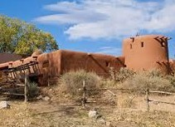open to visits from the public and is regularly rented for large events and for filmmaking. They museum and its land are owned and managed by the El Rancho de Las Golondrinas, Inc. a non-profit organization.

* *The Leonora Curtin Wetland Preserve:* The preserve, also known as the Santa Fe Botanical Garden, is a 35-acre habitat preserve with picnic areas, trails, and interpretive guides. The area includes a spring-fed pond and significant species diversity. It is

managed by the Santa Fe Botanical Garden under a long-term lease with the trustees of El Rancho de Las Golondrinas Trust (the entity which formally controlled the Las Golondrinas Living Museum) and is open to the public.

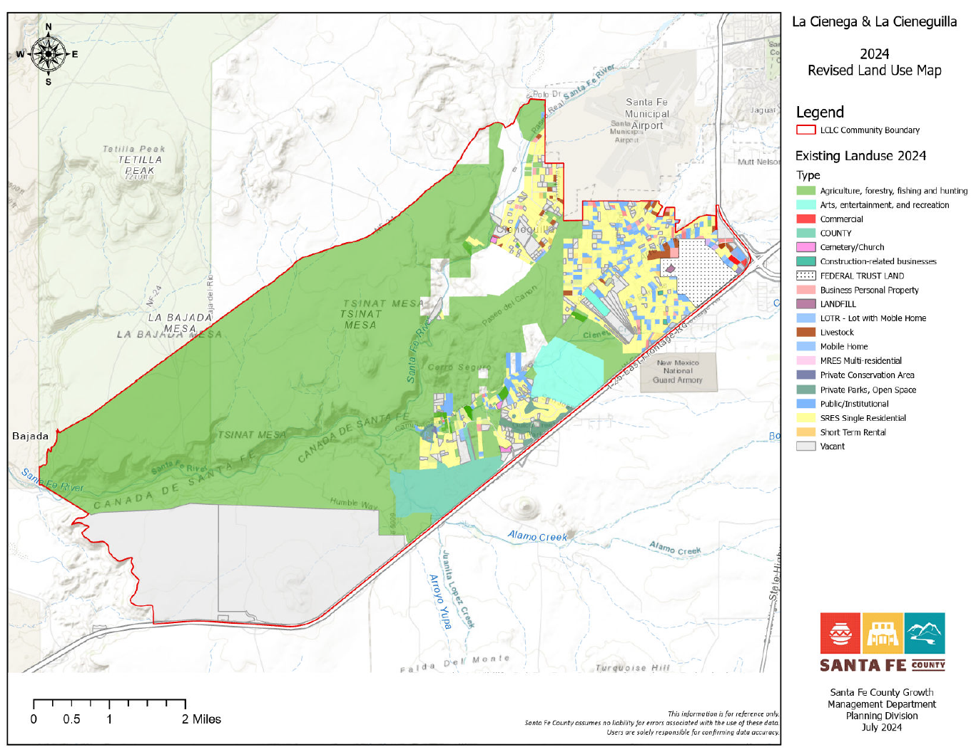

**Figure 2 LC & LC Existing Land Use Map**

# SECTION 2.1.2. LAND USE PLAN AND GROWTH MANAGEMENT **(p. 75)**

## 5.1 INTRODUCTION

The Community Land Use Plan is made up of several components that are interrelated and when viewed as a whole provide a framework to guide development decisions, zoning and regulations, utility extensions and capital improvement projects. The components include:

* Future Land Use Map and Categories which will be used to guide the establishment of base zoning districts and corresponding overlay zones.
* Traditional Agricultural Lands Preservation and Protection Map and recommendations which will be used to guide the establishment of an Agricultural Overlay Zone to incent and promote the conservation and use of irrigated agricultural land and open space.
* Priority County Water Hook-Up Area Map and recommendations based on existing regulations pertaining to the La Cienega watershed conditions, County water extension policies and current and planned alignment of County water lines.
* Roads and Transportation Plan that includes a map, text and graphics illustrating a proposed route for a commuter shuttle and recommended rural road profiles and improvement guidelines.
* Corresponding Community Facilities, Open Space and Trails Map and recommendations.

## 5.2 SUSTAINABLE GROWTH MANAGEMENT GUIDELINES

Guidelines for growth and development based on the principle of sustainability reflect a number of changes in the ways that zoning densities are determined. Many of the original components of the La Cienega and La Cieneguilla Community Plan incorporate sustainability. Preservation and stewardship of the traditional uses of the land are important aspects of sustainability, as are principles of protecting water resources (in both quantity and quality), and supporting the viability of traditional occupations including agriculture and grazing. In addition to these existing components, sustainability addresses the broader use of all resources, including energy consumption, recycling, and the economic stability of the community.

The County’s Sustainable growth Management Plan (SGMP) outlines principles based on long-term sustainability that will guide land use, and provides a framework for zoning for the County’s Sustainable Land Development Code (SLDC). These principles include consideration of water availability and use, terrain, proximity to existing development, energy consumption, and economic viability. Many of the original components of the 2001 La Cienega and La Cieneguilla Community Plan incorporate these principles. Preservation and stewardship of the traditional uses of the land are important aspects of sustainability, as are principles of protecting water resources (in both quantity and quality), and supporting the viability of traditional occupations including agriculture and grazing. This plan update reinforces those principles and supports the goals and policies of the SGMP and in fact implements many of the strategies identified in the SGMP.

In conjunction with the SGMP policies and the SLDC, the following future land use map and provisions is intended to ensure compatibility among various land uses, protects existing property rights pertaining to lot size and density, provides flexibility and certainty, conserves local water resources, protects scenic features and environmentally sensitive areas, enhances rural development patterns, delineates areas to incent agricultural preservation while accommodating the anticipated natural growth of the community and the potential for appropriate commercial development.

The land use categories are consistent with the Future Land Use Categories in the SGMP but are described in greater detail to capture the community’s goals for the plan area and the area’s unique charter. Once adopted The La Cienega and La Cieneguilla Future Land Use Map, (see page 67), corresponding land use categories and provisions refine and amend the SGMP policy framework and Future Land Use Map and as such shall guide future zoning and development decisions.

Development types, such as clustered developments and accessory dwelling units are identified as a means to encourage compact development, encourage historic development patterns and accommodate a variety of lifestyles including multi-generational families living together.

Many provisions and recommended standards identified in this plan are accommodated in appropriate sections of the SLDC.

## 5.3 LAND USE PLAN AND GROWTH MANAGEMENT GENERAL PROVISIONS & GUIDELINES

The following general provisions and guidelines should guide the drafting and adoption of a La Cienega and La Cienega Community District to amend Chapter 9 Community Districts of the SLDC and Official Zoning Map.

Restricted Land Uses based on Water Quality Protection

New development that poses a risk of spills and potential to contaminate surface and ground water systems shall not be permitted within the Planning Area. Non-permitted uses will include gas stations, asphalt batch plants and asphalt production plants, large-scale mining, any warehouse which stores or transfers chemicals, large-scale agricultural operations which stockpile manure or have manure lagoons (e.g.: dairies, horse parks or stables, chicken farms), waste oil recycling, septic tank pumping waste disposal, grease trap waste disposal, large-scale chili processing plants, cheese processing plants, gasoline storage facilities or transfer stations, auto repair facilities, car washes, sludge disposal fields, mortuaries, and slaughter houses.

Restricted Development Areas

Restricted Development Areas simply delineate all of the areas where development will be severely restricted. This can be based on the FEMA maps, the SGMP official maps and the community identified scenic features and environmentally sensitive areas. For example La Cienega Creek, Arroyo Hondo and Alamo Creek and associated bosques could be delineated on a map using FEMA flood plains.

***Steep Slope Areas***

These are areas with greater than 30% slope.

Floodplain Areas

These are the 100-year floodplains that have been mapped by FEMA. Santa Fe County also generally prohibits development within a 75-foot buffer adjacent to the mapped FEMA floodplain boundary, which will also be included.

Wetland Areas And Riparian Habitat

The National Wetlands Inventory will be used for wetland areas and the New Mexico ReGAP Vegetative Land Cover data will be used for riparian areas. “Riparian areas” are the willows, cottonwoods, etc. that are typically found near streams, but do not occur in the water-saturated soils that characterize wetlands.

Archaeological Sites

Archaeological sites identified in the under the Galisteo Basin Sites Protection Initiative shall be protected.

Stream And Arroyo Buffers

Streams will have at least a 25-foot buffer based on the current County Land Development Code requirements.

Critical Habitat Areas

These are typically defined as areas that are essential to the maintenance of viable populations of endangered or threatened animal species. Likely areas that may be included as Critical Habitat Areas are usually within the wetland, riparian, and floodplain zones.

## 5.4 LAND USE PLAN AND GROWTH MANAGEMENT KEY ISSUES

* Community residents have identified that family transfers and variances are sometimes used to divide properties below the minimum lot sizes to avoid subdivision regulations and procedures, contrary to the intent of the family transfer procedure. This allows for increased density on small lots and places higher demands on local water resources to accommodate the new development. More careful examination of the potential impacts of increased densities on local water resources as well as on infrastructure and the area's rural character is necessary before exemptions and variances are granted.
* The rapid development and subsequent changes in land uses, primarily from agricultural to housing, impacts property values and increases tax burdens. This development has benefited some property owners, particularly in the case of large-scale developments. However, the development has also increased economic pressure on families and small-scale landowners to follow the same pattern which has led to piecemeal subdivision of the Planning Area at the expense of the community character. Community residents have identified that continued and uncontrolled development threatens to destroy the rural nature of the community. Additionally, rapid development places strains on limited local natural resources, including water.
* The Planning Area includes various zoning districts including the Traditional Community Zoning District. The maps which depict these different zones, particularly the Traditional Community Zoning District, are interpreted on a case by case basis which has led to confusion on individual zoning decisions. Thus, enforcement is complicated because of unclear boundaries between the various zoning areas.
* Due to increased growth and concerns regarding water quality in the Planning Area, some community members have called for extension of County water and/or wastewater systems into the Planning Area. However, if these systems were expanded in the Planning Area it might be possible to increase housing densities to areas served by both sewer and water. The increased housing densities would lead to urban style intensive development which would further threaten the rural character of the communities in the Planning Area.
* Zoning and density decisions are largely influenced by water availability and the adequacy of septic systems. This is an appropriate approach in the Planning Area due to the need to balance water resources with development. However, the rural character of the communities in the Planning Area is intrinsically linked to development patterns and zoning decisions. Community members in the Planning Area have expressed the importance of including specific consideration of important elements such as local infrastructure, traffic and other impacts of development on the rural communities along with the critically important water resources.
* In the past two decades, zoning changes and land use policies designed for the entire County have helped to direct new growth in the Planning Area. While growth and change are recognized as inevitable and often positive, the rapid development in the Planning Area has also negatively impacted the quiet, rural character of the community. Community members have expressed frustration and exasperation at decisions and policies impacting the community in which they feel community concerns were not addressed or considered. This has led to the impression of disenfranchisement at the community level and served to discourage participation in community and County level decision-making

## 5.5 LAND USE PLAN AND GROWTH MANAGEMENT KEYS TO SUSTAINABILITY

* Land uses within the Planning Area will protect the natural resources, historical resources and rural character of the communities in the La Cienega Valley.
* Increased awareness of the importance of maintaining rural and agricultural character of the communities in the Planning Area.
* Protection and maintenance of clean air and water as community priorities in the Planning Area.
* Incorporate sustainable land practices which preserve the rural, agricultural, ranching, and traditional ways of life within the community.

## 5.6 LAND USE PLAN AND GROWTH MANAGEMENT GOAL

Create a land use plan to protect the natural and historical resources and rural character of the communities in the La Cienega Valley while at the same time position the community to leverage its location adjacent to regional and interstate highway systems, regional transit systems and the airport to increase economic viability.

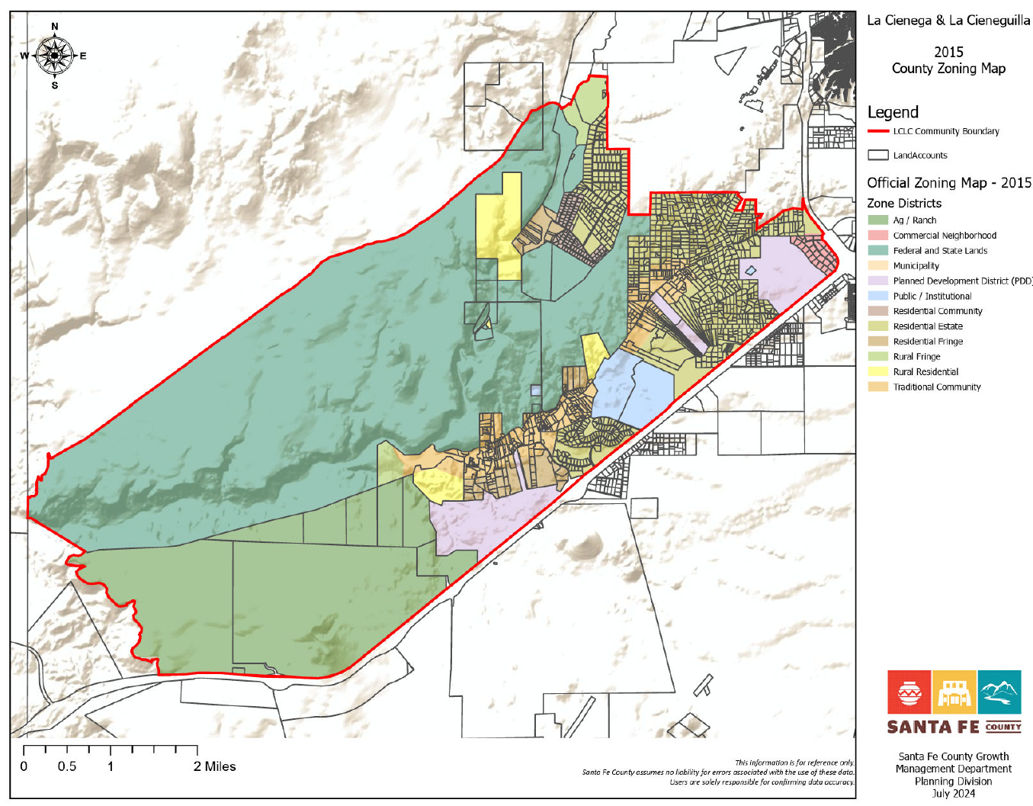

**Figure 7 La Cienega and La Cieneguilla LZoning Map**

## 5.7 LAND USE MAP AND LAND USE CATEGORIES

In conjunction with the SGMP policies and Chapter 2 Planning, of the SLDC, the following land use categories and corresponding land use map will be established for the La Cienega and La Cieneguilla Plan Area.

###### Federal and State Public Lands



Federal and State Lands land use category applies the western half planning area which is primarily under the management of the BLM with a smaller portion under the control of the Forest Service. The area should continue to provide opportunities for hiking, grazing, hunting, mining limited to exiting operations and a natural setting for wildlife and flora. State Land is a large undeveloped property owned and managed by the State Land Office. It should continue to provide opportunities for grazing and hiking. Due to its central location and easy access of Paseo Real, a portion of the area should be considered as a possible site for a new community center with active outdoor recreation facilities including playing fields.

###### Public /Institutional



The Public/Institutional designation pertains to the area associated with the El Rancho de Las Golondrinas Museum and the Leonora Curtin Wetland Preserve. This area should continue to conserve the natural and historic resources and manage visitor impacts with designated operating hours and coordinated traffic management on days with special events

###### Agricultural/Ranch



The Agricultural and Ranch land use category applies to portions of the plan area that are associated with the historic ranch operations The area includes approximately 3,500 acres adjacent to Santo Domingo Pueblo, the adjacent six tracts averaging 140 acres in size for a total of approximately 900 acres. The large tracts should continue to support ranching and associated activities.

Incentives in the form of density bonuses and reduced minimum lot size should be used to encourage compact development in conjunction with major conservation easements.

###### Rural Fringe



The Rural Fringe land use category applies to portions of the plan area that associated with ranch operations. These areas are largely undeveloped.

Incentives in the form of density bonuses should be used to encourage compact development in conjunction with major conservation easements.

###### Rural Residential



The Rural Residential land use designation covers several largely undeveloped agricultural tracts in the plan area, including large grazing properties west of La Cieneguilla. These areas should continue with primarily agricultural uses. Due to the large tracts under single ownership, if residential development is proposed, there is an opportunity to support planned compact residential development in conjunction with conservation easements that set aside land for the purpose of preserving contiguous agricultural land, major archeological sites and natural open space as well as trail easements for community pedestrian and equestrian connections to regional trails and open space.

All new major residential subdivisions and developments should be required to submit a master site plan that protects adjacent properties, provides an environment within the layout of a site that contributes to a sense of community, preserves and enhances natural amenities and cultural resources; protects the natural features of a site that relate to its topography, shape, and size; and provides for a minimum amount of open space to serve the subdivision or development, pedestrian paths and trails; provide an efficient arrangement of buildings, circulation systems, and infrastructure.

Incentives in the form of density bonuses and reduced minimum lot size should be used to encourage compact development in conjunction with hooking up to County water and the establishment of major conservation easements.

###### Residential Fringe



The Residential Fringe land use designation covers sections of the plan area are that south of the Traditional community.

###### Residential Estate



The Residential Estate Land Use Category is designated for areas associated with contemporary residential subdivisions in both La Cienega and La Cieneguilla. This plan anticipates continued infill on the remaining scattered vacant lots; and supports primarily single- family residential development with options for agricultural related uses, home occupations and businesses.

All new major residential subdivisions and developments should protect adjacent properties and provide an environment within the layout of a site that contributes to a sense of community, preserves and enhances natural amenities and cultural resources; protects the natural features of a site that relate to its topography, shape, and size; and provides for a minimum amount of open space to serve the subdivision or development, pedestrian paths and trails; provide an efficient arrangement of buildings, circulation systems, and infrastructure.

###### Residential Community



The Residential Community designation applies to only a contiguous residential area in La Cieneguilla that is almost completely built out on existing 1 acre lots created in the late 70’s. No additional areas are proposed to have this zoning designation.

###### Traditional Community

The Traditional Community Land Use Category is designated for the historic village areas of La Cienega. It is characterized by the historic acequia irrigated farmlands and a concentration of historic homes and traditional development patterns. Agricultural lands and acequias are the defining cultural features of the area and should be preserved and expanded through incentives zoning techniques. The La Cienega and La Cieneguilla Traditional Community Boundary was designated in 1980. In 2001 the boundary was surveyed and was incoroporated in the original La Cienega and La Cieneguilla Plan. The current boundary is proposed to expand along the southwest section to include approximately 113 acres of traditional agricultural land.

The La Cienega Creek and surrounding bosque are the defining natural features of the area. The creek is the primary surface water source for the area and the bosque provides a ground water recharge zone for several springs as well as an important wildlife corridor and riparian habitat. It should be protected from new development and accessible to the community for maintenance and restoration.

The area consists of primarily single-family residential and small scale agricultural development, consistent with historic development patterns and uses. Community facilities, institutional uses, agricultural uses, home businesses and occupations should be allowed anywhere in the area.

Incentives to promote preservation of agricultural land, should be encouraged through the use of land use mechanisms such as TDR’s, conservation easements to preserve contiguous agricultural lands.

**Planned Development (PDD).**



Planned Development Districts are included as a land use category in order to recognize existing Master Plan approvals for properties that do not fit a single land use category. Properties in a PDD may be built out in accordance with their approved master plans.



###### Neighborhood Commercial

The purpose of the Neighborhood Commercial district is to allow for low-intensity convenience retail and personal services, as well as office uses, which are intended to serve and are in close proximity to individual residential neighborhoods.

###### 5.9 GENERAL PROVISIONS AND GUIDELINES

Limitations on the Scope of This Plan

The adoption of this plan is not intended, nor shall it in any way operate, to obligate any entities identified in this plan, including Federal, State, and Santa Fe County in providing resources, initiating support or implementing any project, program or strategy.

Density Transfers

• Density transfer(s) generally are used to protect community assets including but not limited to wetlands, open spaces, springs, watercourses, riparian areas, agricultural lands, acequias, traditional community centers, archeological sites, historical and cultural sites and multigenerational family housing compounds. This could allow developments to transfer minimum lot size densities from an entire piece of property to a specific area of the property in order to protect important community resources such as those listed above. For example if a developer chooses to develop a 10 acre tract in the Traditional Community Zoning District under permitted .75 acre lot size zoning, the county code would allow the developer to divide the land into 13 individual parcels with one dwelling unit per .75 acre parcel. Under density transfers, the developer would be able to cluster the gross density of 13 units on a portion of the property, leaving the rest of the property open and undeveloped.

Home Occupations and Businesses

• The Community Plan recognizes the importance of individuals and families to operate small businesses from their homes. Mixed use development consisting of development that house both residential and non-residential uses on the same property and or in the same structures should be permitted as part of a home occupation. Small-scale arts & crafts and galleries already exist in the community as is demonstrated through the annual gallery tour. The Plan determines that home occupations are appropriate throughout the Planning Area and supports the continuation of existing home businesses and small commercial operations in the Planning Area.

Cell Towers and Antennas

• Standards and regulations for cell towers provided in the SLDC should be reviewed for appropriateness. It should be noted that unique standards and regulations for the plan area may be preempted by federal law which limits permitting authority for cell towers.

Family Transfers

• Because local families are one of the great community resources of the La Cienega and La Cieneguilla Community Planning Area, lots created by inheritance or family transfer should be supported as provided by the SLDC.

Land Protection

* Open spaces set aside for density transfer or other easements for the protection of community assets, as described above, should interconnect to similar sites or potential sites on adjacent properties whenever possible.
* Narrow roads and driveways should follow the natural terrain without creating large cut and fill areas and should be designed with more natural edges, using shoulders, ditches and grassy swales rather than curb and gutter.
* Native vegetation should be preserved, when possible, on development sites and local native plants used for landscape buffers and screening.

Acequia Protection

* Development should be set back from the six foot (6') maintenance right of way of the traditional acequias to maintain the integrity.
* Applications for development within twenty-five feet (25') of an acequia should be reviewed by the affected Acequia Association prior to the issuance of permits. The County should work with the Acequia Associations to develop a contact list for review of proposals.

Ridgetop Protection

* In order to more effectively protect the horizons surrounding La Cienega and La Cieneguilla, ridgetops in the Planning Area should not have unnecessary development.

**Noise and Lighting**

* Noise and lighting standards should be strictly enforced to protect the quiet nature and dark skies of the community.

**Community Notification of Water Impacts**

* Development should ensure adequate water resources.

# Appendix **(p. 100)**

###### Plan Area Zoning: Santa Fe County Ordinance No. 2002-9

Summarized below are general zoning and development regulations that pertain to land use, density, and related environmental aspects of development based on Santa Fe County Ordinance No. 2002-09 for the Planning Area of La Cienega and La Cieneguilla.

*Acequia Protection*

* Acequia Association Review of New Development: Prior to issuance of development permits for activities that may interfere with acequia operations including fences, walls, grading, drainage and septic systems, applications for development within twenty- five feet (25') of an acequia must be reviewed by the affected acequia association.
* Acequia Setback Requirements: No new structures or permanent fences or walls that will impair or obstruct normal operations of an acequia shall be permitted within six (6) feet of community acequias.

*Agriculture Development and Tax Valuation Regulations*

* Per New Mexico State Statute, Santa Fe County taxes agricultural lands at a lower rate than other land uses in order to help prevent the loss of agricultural lands. One acre of nonimproved land is the minimum acreage that can be used as agriculture, and 80 acres minimum for grazing. Property owners interested in the special agricultural assessment must demonstrate that their land is primarily used for the production of plants crops, trees, forest products, orchard crops, livestock, poultry or fish, or proof that the livestock has access to all of the agricultural land for the tax year. [Note: federal definitional standards for farms and farmers for income and estate tax purposes differ from local standards].
* Agricultural sales and roadside stands are allowed in the planning area with a permit.

*Residential Development*

* Residential water use is limited to .25 acre feet a year throughout the plan area. The request for additional water consumption requires a water budget and proof of 100 year water supply.
* The maximum density shall not be increased even when community water and sewer systems are provided except where density transfer or TDR’s are used to protect sensitive lands or preserve community assets.
* Lot Coverage; the total roofed area of principal and accessory structures, shall be no more than twenty percent (20%) of the total lot area.
* Allowable uses within the planning area include residential, agricultural and mixed uses if

associated with home occupations.

*Hydrologic Zones and TC Zoning District*

There are three existing hydrologic zones and one zoning district under the existing Land Development Code for residential development that currently regulate density in the plan area: • Homestead Hydrologic Zone:

* + Allows 1 dwelling unit per 160 acres. With proof of 100 year water supply through a geohydrologic reconnaissance report, and application of water use covenants, the maximum density may be increased to one dwelling unit per 40 acres. If an adequate 100 year supply of water, and no impairment to neighboring wells, is proven by an on-

site geohydrological well test, land may be further divided to a minimum of 2.5 acres per 1 dwelling unit.

* Basin Fringe Hydrologic Zone:
  + Allows 1 dwelling unit per 50 acres. With proof of 100 year water supply through a geohydrologic reconnaissance report, and application of water use covenants also known as La Cienega Watershed Conditions, the maximum density may be increased to one dwelling unit per 12.5 acres. If an adequate 100 year supply of water but no impairment to neighboring wells is proven by an on-site geohydrological well test, land may be further divided to a maximum of 2.5 acres per dwelling unit.
* Basin Hydrologic Zone:
  + Allows 1 dwelling unit per 10 acres. With proof of 100 year water supply through a geohydrologic reconnaissance report, and adoption of water use covenants also known as La Cienega Watershed Conditions, the maximum density may be increased to one dwelling unit per 2.5 acres.

* La Cienega Traditional Community District:
  + The traditional community district is primarily a residential zoning district requiring a minimum lot size and density of one unit per 3/4 acres.

*Commercial Zoning Provisions*

* County Ordinance 2002-09 limits commercial zoning to those existing at the time of adoption. These properties are restricted to uses, intensities and densities identified on their approved master plans. This includes the Santa Fe Downs property which is zoned for outdoor recreational uses and a few lots fronting Erica Road.

* Expansion or establishment of new commercial development on properties with commercial zoning are subject to the La Cienega Watershed Conditions and restricted to .35 acre of water per year per acre if on a domestic well. The code also requires a water resources analysis at the time of application. The analysis must demonstrate secured access to a 100 year supply of water as well as secured water rights, as required by state law and/or the code to meet all current and projected demands for the business operation.

* Lot Coverage: The total roofed area of principal structures and accessory structures, roadways, driveways, walkways and parking facilities shall be no more than sixty percent (60%) the total lot area.

*Prohibited Commercial Development*

* New developments that pose a risk of contaminating surface and ground water systems shall not be permitted within the planning area. Prohibited uses will include but not be limited to: gas stations, asphalt batch plants and asphalt production plants, large-scale mining, any warehouse which stores or transfers chemicals, large-scale agricultural operations that stockpile manure or have manure lagoons (e.g.: dairies, horse parks or stables, chicken farms), waste oil recycling, septic tank pumping waste disposal, grease trap waste disposal, large-scale chili processing plants, cheese processing plants, gasoline storage facilities or transfer stations, auto repair facilities, car washes, sludge disposal fields, mortuaries, municipal and/or hazardous landfill, and slaughter houses.

*Home Occupations*

* Mixed use development and small commercial operations consisting of development that house both residential and non-residential uses on the same property and/or in the same structures are permitted throughout the plan area. There are standards related to parking, number of employees and percent of total area of a residence that can be occupied by the business. Smallscale retail establishments, such as arts and crafts stores, restaurants or galleries may be permitted as part of a home occupation. The scale is defined by the number of vehicle visits per day with no more than thirty (30) vehicle visits per day and no- more than ten (10) vehicle visits per hour.

*General Provisions for All Development Types*

* Utilities- Gas, Electric and Telecommunications: All new and replacement utility lines and

fixtures must be installed underground.

* Limits on light and noise pollution.

* Landscaping: Recommendations and requirements for preserving native plants, water conservation, use of xeriscape materials and principles, rainwater collection and storage systems, reuse of gray water, storm water recharge.

* Septic Tanks: All new septic tanks shall meet or exceed existing New Mexico Environment Department (NMED) and County standards and be equipped with an above ground access port.

* Ridgetop Protection: Building on slopes greater than 15% and ridge tops comply with Code

requirements such as setbacks, screening and buildable areas.

*La Cienega Watershed Conditions*

* The La Cienega and La Cienega Planning District Ordinance implemented many of the strategies identified in the 2001 Community Plan pertaining to water resources including reaffirming and refining the “La Cienega Watershed Conditions.” (For more information see Lots Subject to the La Cienega Watershed Conditions below ).

###### Other Relevant Ordinances and Regulations

* Santa Fe County Ordinance 2000-7: Confers designation of La Cienega and La Cieneguilla as a *Traditional Historic Community (THC)* under state law. This ordinance prevents annexation by the City of Santa Fe. The Boundary of the La Cienega THC is congruent with the 2001 La Cienega and La Cieneguilla Plan Area Boundary and will remain in effect with the adoption of this plan.

* Environmental Requirements: It should also be noted that there are additional environmental requirements in both the SCLD 1996-10 and the SLDC 2013 that address flood hazards, liquid waste disposal, terrain management, air quality, noise, water supply and solid waste.