# **SECTION 2.3. AGRICULTURE & RANCHING**

## 3.3 AGRICULTURE (p. 45)

#### 3.3.1 Introduction

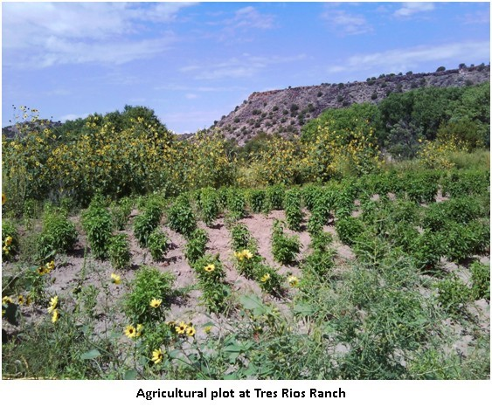Farming, ranching, and the acequia irrigation systems have been the defining characteristics of land use and settlement of communities in the La Cienega and La Cieneguilla Planning Area for hundreds of years. The presence of *ojos* or springs that formed the area's *cienegas* or marshes have been tapped by settlers to irrigate crops, water livestock, and sustain households. The agricultural and community traditions formed around acequias have defined where people built homes and how the community grew since at least the early 1600s. Collective maintenance and management of acequias was a primary basis of community governance along with stewardship of both land and water resources needed to sustain the communities. The waterways and irrigation of fields has also led to the development of unique and vibrant riparian ecosystems. The rich legacy of agricultural production in the Planning Area includes grazing in dry upland areas as well as harvesting food, herbs and tree crops along the waterways and acequias.

Agriculture and associated farm activities are part of the history, culture, economic base and tradition of the area. Additionally the agricultural economy is still an important and component of the plan area and the County as a whole. Many residents have both fulltime employment outside the agricultural sector and engage part time in tending to the orchards, vegetable farms and pastures of the plan area which contributes to the household food budgets and a diverse economy. A number of residents still earn their living entirely from farming. Without taking steps to revitalize local agriculture, residents fear that continued development will eliminate the option of farming in the valley and the communities will permanently lose agriculture along with the rural character of the Planning Area. Maintenance of agricultural production and protection of agricultural land are primary goals of this Plan. (See Maps 5 & 6 – Irrigated Agricultural Lands)

According to a hydrographic survey of the area completed by the State Engineer's Office in 1976, approximately 150 acres of land were potentially irrigable by community acequias, surface water sources such as springs, streams and rivers. Out of that 150 acres of acequia irrigated farmland, an estimated 80 acres are actively under cultivation. There lands used for grazing located primarily on the large ranch holdings and public lands in the plan area.

Several factors will continue to positively and negatively influence agricultural production in the plan area:

* The growing demand for organic locally grown food by Santa Fe County residents and visitors has steadily grown. The Santa Fe Farmers Market and the La Cienega Valley Growers' Market provide local venues for selling produce.
* New technologies applied to weed control and water conservation.
* Continue conversion of agricultural lands into home sites.
* Continued drought conditions and the drawdown of water supplies.
* A labor force that is aging.
* The selling off of water rights associated with the acequia systems.

The demand created for new housing drives real estate prices up as well as property taxes on undeveloped property. Higher property taxes and low returns from agriculture create economic pressure on Planning Area residents. The pressure encourages the sale and development of land traditionally used for agricultural purposes. Once land is converted to housing, it is virtually eliminated from future use in agriculture.

Local residents continue to look for viable means to preserve agricultural lands and protect them from development. Potential avenues include:

* Transfer of Development Rights Programs
* Conservation Programs
* Land Trusts
* Institutional Ownership
* Traditional Community Preservation Programs

#### 3.3.2 Agriculture Key Issues

* Agricultural land, including irrigated fields, orchards, and grazing areas, are being lost to new development. This significantly alters the local communities, as agricultural activities are integral parts of the rural character and historical heritage of the La Cienega and La Cieneguilla Planning Area.
* The changing agricultural economy and decreased use of agricultural lands helps encourage the conversion of farmlands to other development. A lack of education and promotion of economically viable agricultural practices exacerbates this problem for the typical small-scale farmer in the Planning Area.
* Lands managed by the Bureau of Land Management and the New Mexico State Land Office (NMSLO) currently provide opportunities for agricultural uses, such as grazing, within the Planning Area. However, if these lands should change to private ownership through land swaps or state development, they could be removed from use in the communities' traditional grazing practices.
* The drop in spring flows in and near the Planning Area has dramatically impacted local acequias and has made the practice of irrigation difficult because there is less water available for irrigating than the total number of irrigable acres. Residents and longtime irrigators have identified the drop in available water for irrigation as one of the biggest obstacles to maintaining agriculture in the area.

#### 3.3.3 Agriculture Keys to Sustainability

The Community supports a number of the keys to sustainability expressed in the County’s Sustainable Growth Management Plan (SGMP), including:

* SGMP Goal 14: Preserve, support, promote and revitalize agriculture and ranching as a critical component of the local economy, culture and character.
* SGMP Strategy 14.1.5: Create an inventory of agricultural lands and conduct a land suitability analysis to identify agricultural potential and determine high priority of protection for agricultural soils and other sensitive arable lands, especially historical agricultural land with water rights.
* SGMP Policy 14.2: Support the practicality of agricultural uses to include financing tools to support viability of agriculture.
* SGMP Strategy 14.2.1: Create a transfer of development rights program for agriculture and ranch lands.
* SGMP Strategy 14.2.2: Assess and develop resource tools such as conservation easements, improvement districts, development of impact fees and grants to support the viability of agricultural uses.
* SGMP Strategy 14.2.3: Coordinate with local communities and organizations to promote the development of agricultural products and markets, including the development of farmers markets, buy-local campaigns, and a local products website to market and distribute fresh goods.
* SGMP Strategy 16.1.1: Develop education programs and outreach to support agriculture and ranching. Include materials on organic farming, year round farming and better range management practices.

In Addition, the Community Plan includes these area-specific agricultural keys to sustainability:

* Protect all agricultural lands in the Planning Area.
* Maintain and enhance active agricultural production in the Planning Area.

## 5.11 TRADITIONAL IRRIGATED AGRICULTURAL LAND PRESERVATION (p. 82)

Maintenance of agricultural production and protection of agricultural land are primary goals of the community. Conversion of irrigated land into home sites often results in land that is no longer irrigated and left fallow shrinking the overall health of the agricultural lands. As an important connection to the history and an important aspect of the community’s rural character, the irrigated agricultural lands of the valley deserve special design guidance and incentives to individual property owners who continue to keep and/or assemble land for agricultural uses.

There is a need is to promote the integrity of historic agricultural lands in the valley by incenting individual property owners to assemble and set- aside consolidated tracts of irrigated agricultural land. The strategy is to increase the value of irrigated agricultural lands by establishing zoning incentives, density bonuses, and transfers in conjunction with agricultural conservation.

LCLC Traditional Irrigated Agricultural Lands Maps in Figure 4 and 5 identifies parcels that contain irrigated lands as identified by the OSE Santa Fe River Hydrographic Survey of 1972. Of the total acreage, approximately 150 acres are identified in the 1972 OSE Survey as surface or acequia irrigated land and should be considered as *qualifying Traditional Irrigated Agricultural Lands,* for which residential density bonuses and/or transfers can be established.

It should be understood that the parcels depicted on the map include land that is not currently or historically acequia or surface irrigated land. Buildable areas that employ density bonus’s should be encouraged to locate outside of the *Traditional Irrigated Agricultural Lands*; this reflects traditional patterns in the acequia landscape where prime farmland was preserved for farming. Development, including residential development, was relegated to the drier areas, the ejidos & altitos, above the acequia systems.

Residential Density Bonuses and Transfers

* On properties where irrigated agricultural land is preserved (by conservation easement, setaside, or other means) from any future development, properties may qualify for a residential density bonus (increase in the number of dwelling units allowed by the base zoning district or overlay) and/or the right to transfer density in the form of dwelling units to qualifying developments (See TDR Program above).

* Preserved agricultural lands should be registered as conservation easements or no build-areas recorded on the plat.

* Residential density bonuses and transfers will allow for increases to base zoning densities for residential development and in many cases decreases in minimum lots sizes.

* In order to accommodate density bonuses the County should first develop minimum regulations for the divisions of land as well as site development standards and regulations.

* Regulations and standards for land division and site development should include provisions for the following:

* + Development in the Set-aside of Qualifying Traditional Irrigated Agricultural Land, ("no build area" and/or agricultural conservation easement):

* + Land used for roads, parking and private yards should not be counted as part of the set aside. No buildings or structures should be permitted in the set aside except as incidental to agricultural uses such as green houses, sheds or corrals. Underground and above ground utility easements and land accommodating septic systems, acequias, drains or laterals can be counted as part of the set-aside.

**Development in Buildable Areas**:

Procedures, regulations and standards based on the intent and purpose of the underlying land use designation or base zoning districts should be established to regulate and guide development with increased density due to the use of density bonuses. Particular attention must be paid to water supply and wastewater treatment in conjunction with density and soils suitability. It is anticipated that high performing septic systems and shared wells or hook up to County or community water and waste water systems will be necessary for increased density on most sites.

Incentives should be increased for density bonuses that are transferred to qualified developments outside of parcels associated with the Traditional Irrigated Agricultural Lands.

Density bonuses in the form of residential units should be established if development right is transferred to a qualifying development outside of a parcel associated with Traditional Irrigated Agricultural Land. Transfer of the development right should be submitted as part of the development application for the qualifying development and include the set-aside of qualifying Traditional Irrigated Agricultural Land in the form of an agricultural conservation easement and/or no-build area depicted on an approved site plan or subdivision plat.

## **5.10 TRANSFER OF DEVELOPMENT RIGHTS (TDR) PROGRAM (p. 80)**

The purpose of the TDR Program ~~TDR’s~~ is for the conservation of natural, scenic, and/or agricultural qualities of open land, areas of special character or specific historic, cultural or aesthetic ~~interest or~~ value, or encvi~~i~~ronmental protection such as watershed, steep slopes, floodplains, etc. ~~The following are suggested guidelines for the creation of a TDR program. Actual program regulations will l be developed in conjunction with the County, based on current conditions.~~

~~A TDR program will be developed in order to preserve:~~

* ~~Traditional agricultural lands for agricultural use.~~
* ~~Archeological or cultural sites as identified by Federal or New Mexico State registry.~~
* ~~Other sites as determined by future community review and amendment of this Plan.~~
* ~~Open Space property.~~

Participation in the TDR ~~p~~Program ~~will be~~is voluntary~~, and no development restriction or other penalty should be imposed by non-participation.~~

.

~~The initial implementation of the TDR program should prioritize the preservation of traditional agricultural lands for agricultural use.~~

~~The program should identify Sending and Receiving Areas (SAs and RAs) within the La Cienega Planning Area.~~

**Sending Areas (SAs)**

~~SAs are specific properties eligible to send or transfer their development rights to other properties. Each property shall be evaluated by means of professional appraisal or other acceptable valuation method. The valuation should be used to determine the number of development rights, or Development Units, for the property. The valuation is not necessarily the “selling price” or “market value” of the property or the Development unit.~~

**Proposed Sending Areas:**

***A) Traditional Agricultural Lands***

* Properties identified as having traditional agricultural lands should be identified and mapped. A land parcel need not be identified as 100% traditional agricultural land to be qualified for the TDR program. The portion of a qualifying land parcel that is identified as having traditional agricultural use shall be used to determine the Development Units available. For example, if a five acre parcel has two acres of traditional agricultural land, the two acres shall be used in calculating the number of Development Units available to the parcel. Development rights transferred from the parcel should only affect the two acres of agricultural land, and the remaining three acres of the parcel should maintain base zoning density.

* To qualify as traditional agricultural land, the land must be identified as having long-term agricultural use. Surface irrigation water rights from current or past acequias, or traditional use of acequias waters with or without identified rights, may be used to identify qualifying lands.

Traditional surface water irrigation from local streams and rivers, whether by acequia or not, may be used to identify qualifying lands. ~~Other means of qualification of lands may be employed.~~

***B) Archeological or Cultural Sites***

* Properties identified as having archeological or cultural sites should be identified and mapped. A land parcel need not be identified as a 100% archeological or cultural site to be qualified for the TDR program. The portion of a qualifying land parcel that is identified as having an archeological or cultural site should be used to determine the Development Units available.

* To qualify as an archeological or cultural site, the site must be identified by federal or New Mexico registry of such sites. Sites note currently identified by federal or state registry may become eligible if they are included in future Federal or State registries.

***C) Open Space***

▪ *Properties or portions of properties can qualify for the TDR program to maintain continuous sections of open space for viewscapes, and trails.*

o *La Bajada Ranch may be used as a sending area to maintain open space.*

***D) Tres Rios Ranch portions included in the Traditional Community***

▪ *Portions of the Ranch that are within the Traditional Community have been included in the Traditional Community because of the existing agricultural nature and history of the property. To preserve this site for historical and agricultural uses the site has been identified as a Sending Area.*

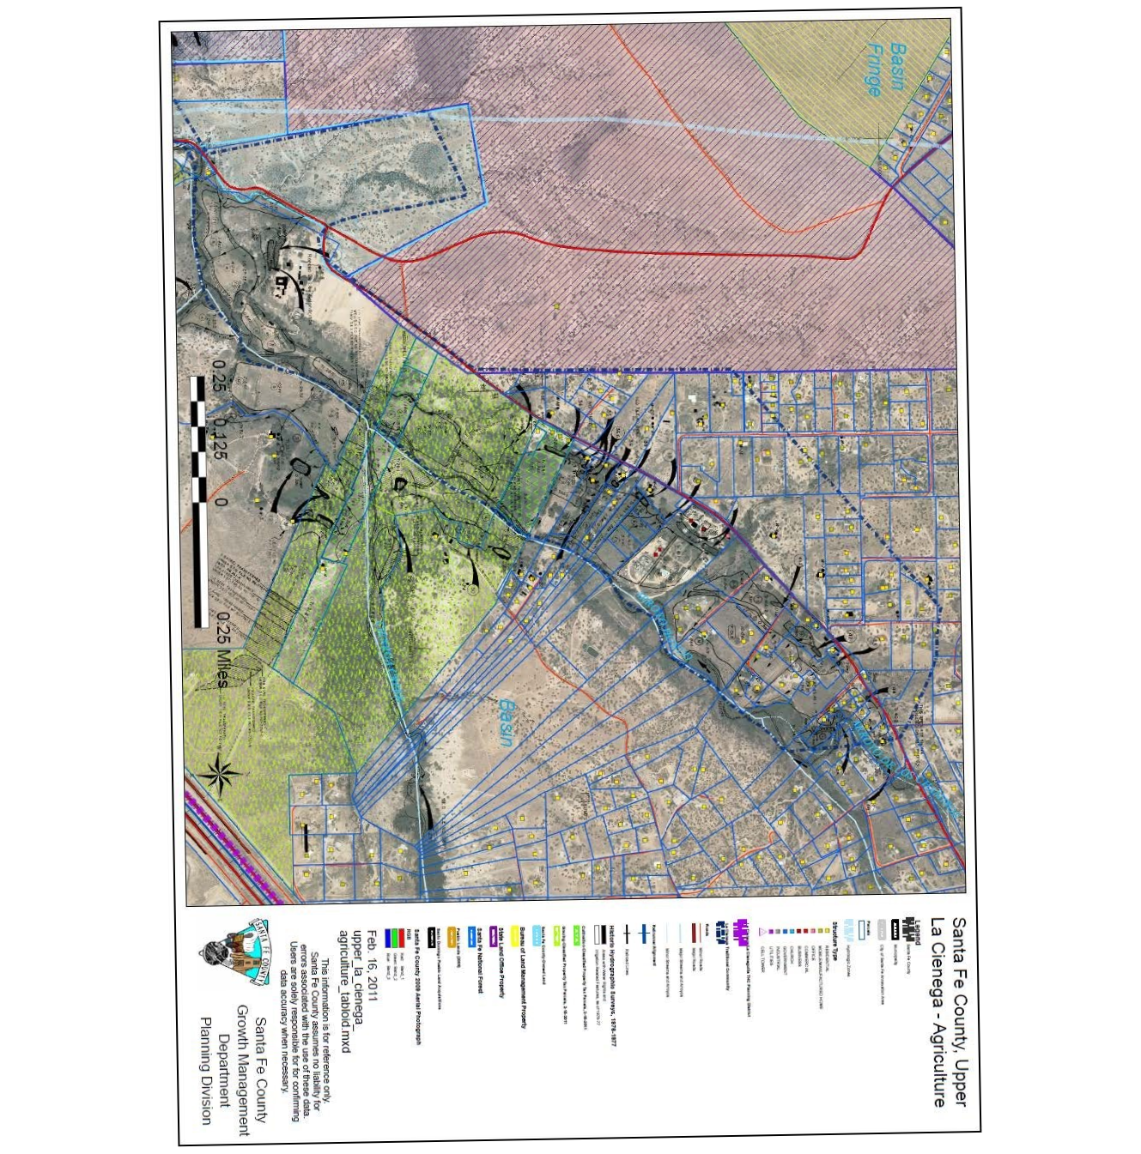

**Figure 4 Upper La Cienega Agriculture Map.**

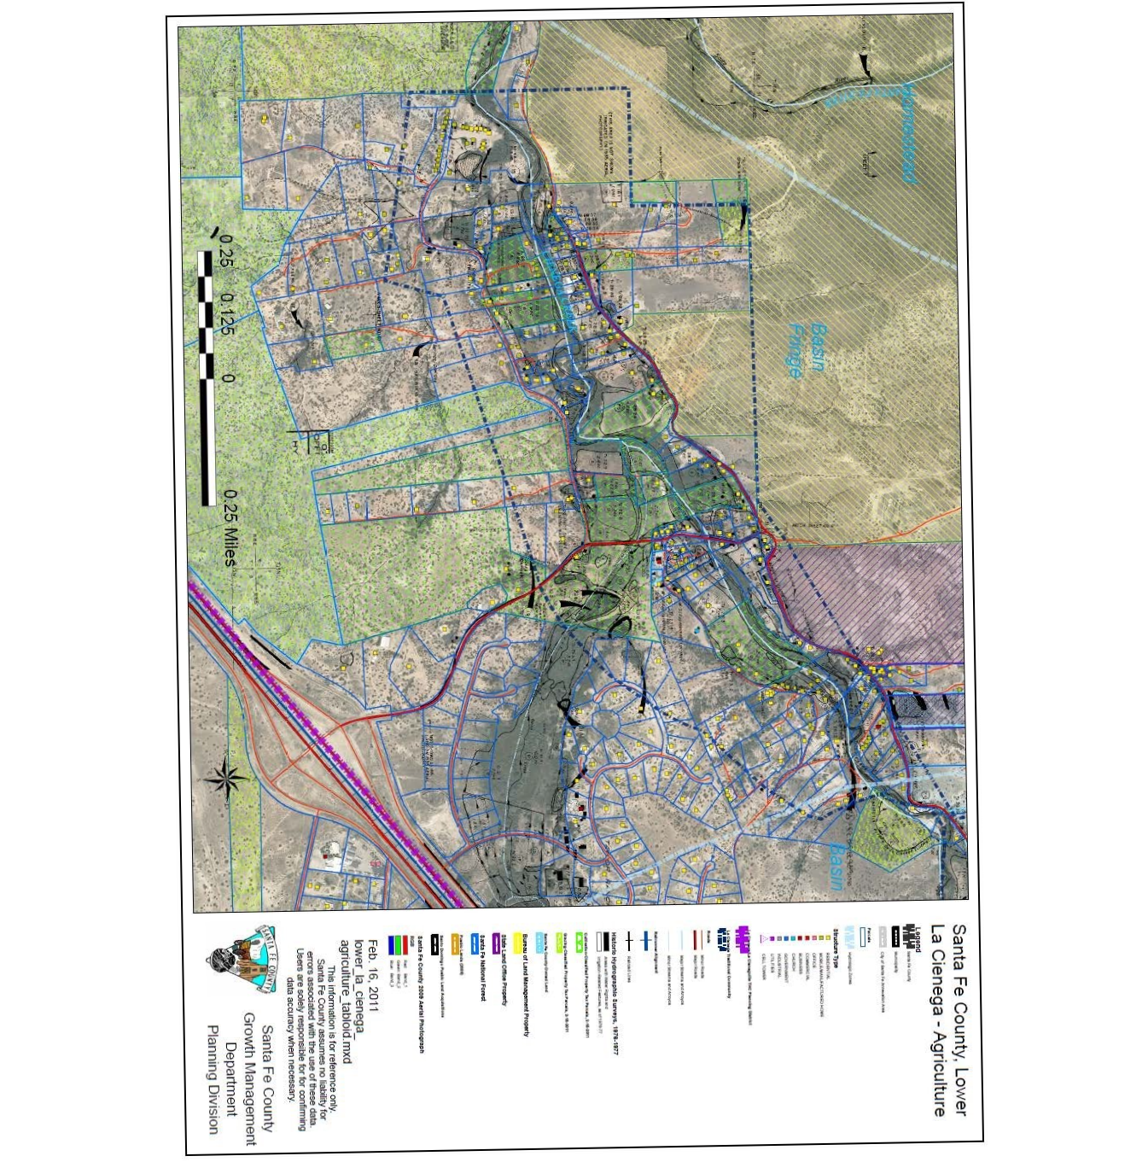

**Figure 5 Lower La Cienega Agriculture Map**